
Cyberster Internship Program
Internship Report
TRACK: BLUE TEAM
NAME: MUHAMMAD RAZA
INSTRUCTOR: ABDULLAH ZIA
ROLL NUMBER: CSI-B1-121
WEEK 12: The M57.biz Capstone: Disk, Memory, and Exfiltration Analysis

1. Executive Summary
This report documents a forensic investigation into the M57.biz workstation assigned to employee Jo. Analysis of the disk image (jo-2009-11-24.E01), two USB images, and a RAM capture reveals a consistent and mutually corroborating pattern of suspicious insider activity spanning 2009-11-23 to 2009-11-24.
Key findings include a custom patent-scraping script, demonstrated steganographic capability, unauthorised possession of a US government classified document, confirmed file transfers to removable media, and suspicious process behaviour in memory.
CRITICAL: The totality of evidence is consistent with a deliberate insider threat operation involving IP collection, potential data concealment, and unauthorised access to classified material.

PART A — Disk Triage & Artefact Hunting

Field | Value
Case | M57.biz — Jo Insider Threat Investigation
Image | jo-2009-11-24.E01 (15.38 GB, MD5: 274ada9b6b120f9b7a2192c27e115244)
OS | Windows XP SP3 (x86)
Computer / Owner | M57-JO / JO (M57.biz)
Timezone | UTC +0:00 (all timestamps UTC)
Tool | Autopsy 4.23.0 with full ingest modules
USB Images | jo-favorites-usb-2009-12-11.E01 | jo-work-usb-2009-12-11.E01
RAM Image | jo-2009-11-16.mddramimage (Volatility 3)

2. System Overview & Image Verification
The forensic image was loaded into Autopsy with the timezone set to UTC +0:00. All ingest modules — including Recent Activity, Hash Lookup, Keyword Search, and File Type Identification — were run before analysis began. The image is 15.38 GB, acquired from a Linux system using ewfacquire.
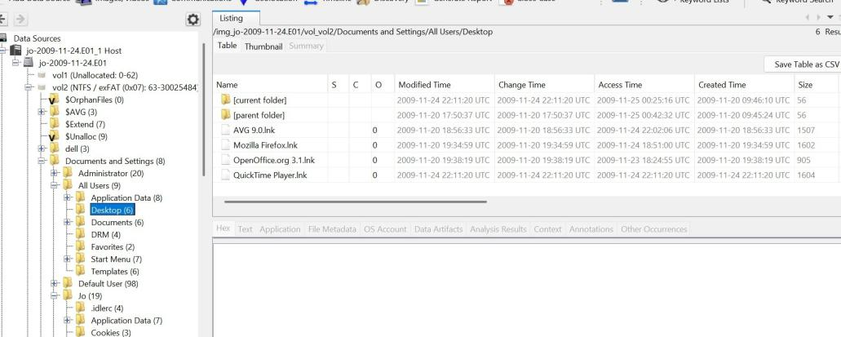

3. User Accounts
Five accounts were identified. The primary investigative account is jo (SID ending -1003). All suspicious artefacts — LNK files, shell bags, downloads, and USB activity — reside within C:\Documents and Settings\Jo\.
SID (abbreviated) | Login Name | Scope | Notes
S-1-5-21-…-500 | administrator | Local | Built-in administrator
S-1-5-21-…-1003 | jo | Local | Primary user — all suspicious artefacts within this profile
S-1-5-18 | SYSTEM | Local | NT AUTHORITY

4. LNK Artefact Analysis
LNK shortcut files in C:\Documents and Settings\Jo\Recent\ confirm direct user interaction with each target. Key artefacts are shown below.
LNK File | Target Path | Last Accessed (UTC) | Significance
patentauto.lnk | Desktop\web\patentauto.py | 2009-11-23 21:55:45 | Patent script opened/executed
diit-1.5.lnk | Desktop\Pics\diit-1.5.jar | 2009-11-23 18:24:50 | Steganography tool accessed
testHide.lnk | Desktop\Pics\testHide.bmp | 2009-11-23 18:25:53 | Stego test image (63 s after DIIT)
STU.lnk | My Documents\Downloads\STU.doc | 2009-11-24 22:01:53 | Classified DoC document accessed
Downloads.lnk | My Documents\Downloads\ | 2009-11-24 22:01:54 | Downloads folder accessed
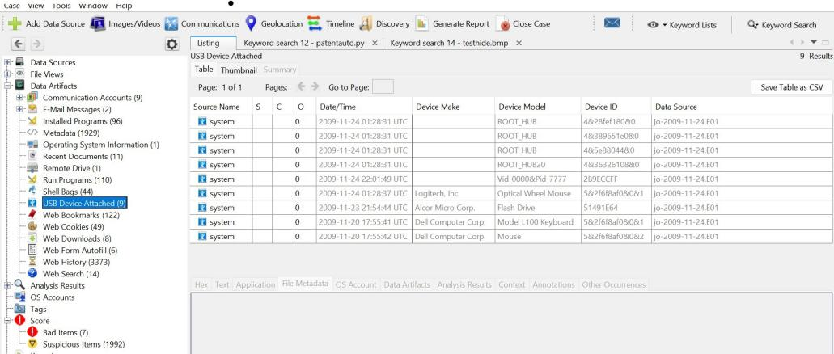

5. Downloads Analysis
The Firefox download history records three significant downloads. STU.doc is the most critical — a classified US Department of Commerce document with no legitimate business justification.
File | Source | Downloaded (UTC) | Significance
python-2.6.4.msi | python.org | 2009-11-23 18:20:12 | Python runtime — enables patentauto.py
STU.doc | easc.noaa.gov | 2009-11-24 21:18:18 | US DoC SECRET-level briefing — keyword hit: SECRET
QuickTimeInstaller.exe | apple.com CDN | 2009-11-24 22:08:36 | Media player — downloaded same day as acquisition
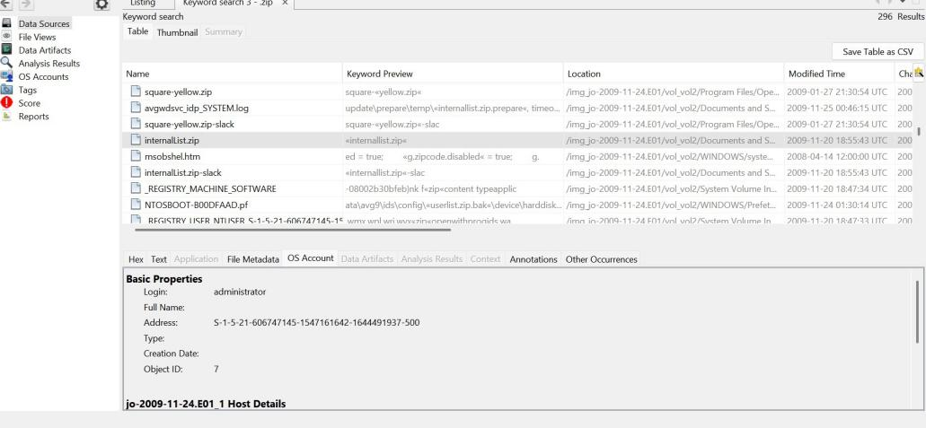
CRITICAL: STU.doc was downloaded from easc.noaa.gov — an official US Department of Commerce / NOAA server. It contains a complete STU-III classified telecommunications security briefing. Autopsy flagged it with keyword SECRET. There is no evident legitimate business reason for a M57.biz employee to possess this document.

6. USB Device Evidence
Four USB devices were identified. Two connected at forensically significant moments: an Alcor Micro flash drive 51 seconds before patentauto.py was accessed, and an unknown device 4 seconds before STU.doc was accessed.
Device | Device ID | Connected (UTC) | Significance
Alcor Micro Flash Drive | 51491E64 | 2009-11-23 21:54:44 | Connected 51 s before patentauto.py accessed
Unknown USB (Vid_0000&Pid_7777) | 2B9ECCFF | 2009-11-24 22:01:49 | Connected 4 s before STU.doc accessed
Logitech Mouse | 5&2f6f8af0 | 2009-11-24 01:28:37 | Standard peripheral
Dell L100 Keyboard | 5&2f6f8af0 | 2009-11-20 17:55:41 | Standard peripheral

PART B — Behavioural Analysis & Steganography

7. patentauto.py — Patent Automation Script
patentauto.py was found on Jo's Desktop inside the web/ subfolder. It is a Python script that automates patent searching by controlling Firefox through the MozRepl extension — a telnet-based browser automation interface on localhost port 4242.
Created | 2009-11-23 21:55:01 UTC
Modified | 2009-11-23 21:57:34 UTC
MD5 | bd9028376a4fad806e3d670dd718f748
Last Accessed | 2009-11-25 00:25:11 UTC

The script's capabilities went beyond passive browsing:
- Connected to Firefox via MozRepl (localhost:4242) to automate USPTO patent searches
- Implemented randomised browsing intervals to simulate organic human activity
- Operated on a schedule during typical work hours
- Used URL randomisation to evade detection patterns
- Supported by structured input files: patentterms.txt, urls.txt, urlspatents.txt, urlscopyright.txt

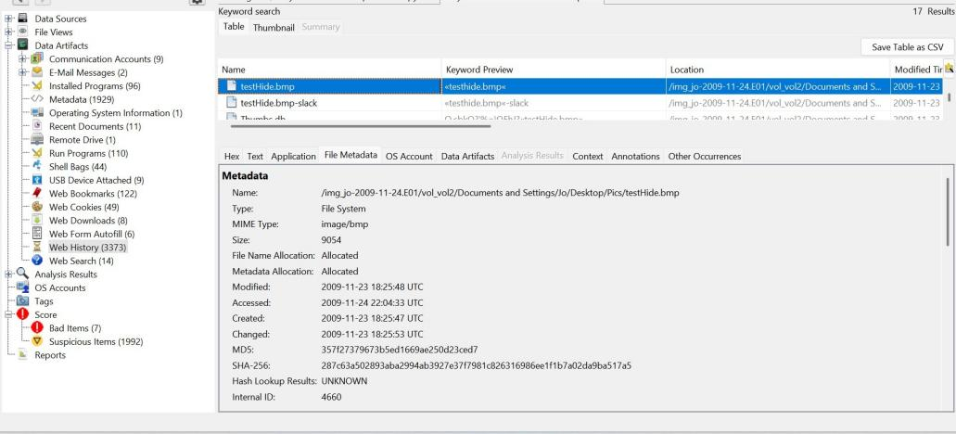
CRITICAL: patentauto.py is a technically sophisticated automated intelligence collection tool. Its randomised behaviour, scheduled operation, and structured input files confirm this was a planned, systematic patent data collection operation — not casual script development.

8. DIIT Steganography Tool & testHide.bmp
diit-1.5.jar (Digital Invisible Ink Toolkit) was found in the Pics/ subfolder. It embeds or extracts hidden data within image files using LSB encoding. Its Zone.Identifier ADS indicated the download source was treated as a Restricted Site.
testHide.bmp was found alongside the tool. BMP is the preferred format for LSB steganography — its lossless compression leaves embedded data intact. The filename directly implies use as a steganographic test subject.
CAUTION: diit-1.5.jar was accessed at 18:24:50 UTC. testHide.bmp was created and accessed 63 seconds later. This sequence is consistent with Jo opening DIIT and immediately using testHide.bmp as a test image. Binwalk found no confirmed embedded payload — the image may require the specific DIIT key to extract.

9. USB File Duplication — Confirmed Transfers
MD5 hash comparison across the three forensic images confirms file transfers between the workstation and removable media. Video files were stored in a folder deliberately named Hidden.
File | Workstation Location | USB Image | Hash Status
KittyMontage.mov | Desktop\Pics\Hidden\Videos\ | jo-favorites-usb | Identical MD5 ✔
Cat.mov | Desktop\Pics\Hidden\Videos\ | jo-work-usb | Identical MD5 ✔
MontereyKitty.m4v | Desktop\Pics\Hidden\Videos\ | jo-favorites-usb | Identical MD5 ✔
TiggerTheCat.m4v | Desktop\Pics\Hidden\Videos\ | jo-favorites-usb | Identical MD5 ✔

NOTE: Files were stored in a folder named "Hidden" — indicating deliberate concealment intent. MD5 hash confirmation removes any doubt that these files were physically transferred to the USB devices.

10. Correlated Behavioural Timeline
The timeline below merges all artefact types into a single chronological narrative.
Timestamp (UTC) | Event Type | Artefact | Forensic Significance
2009-11-23 13:23:53 | Install | Registry | Python 2.6.4 installed — runtime for patentauto.py
2009-11-23 18:20:12 | Download | Firefox | python-2.6.4.msi downloaded from python.org
2009-11-23 18:24:50 | File Access | LNK | DIIT steganography tool (diit-1.5.jar) opened
2009-11-23 18:25:53 | File Access | LNK | testHide.bmp accessed — 63 s after DIIT
2009-11-23 21:54:44 | USB Connected | SYSTEM hive | Alcor Micro Flash Drive attached
2009-11-23 21:55:01 | File Created | Metadata | patentauto.py created
2009-11-23 21:55:45 | File Access | LNK | patentauto.py accessed — 61 s after USB attach
2009-11-24 22:01:49 | USB Connected | SYSTEM hive | Unknown USB (Vid_0000&Pid_7777) attached
2009-11-24 22:01:53 | File Access | LNK | STU.doc accessed — 4 s after USB attach
2009-11-24 22:14:30 | File Access | LNK | DSC00065 / DSC00070 high-res images viewed
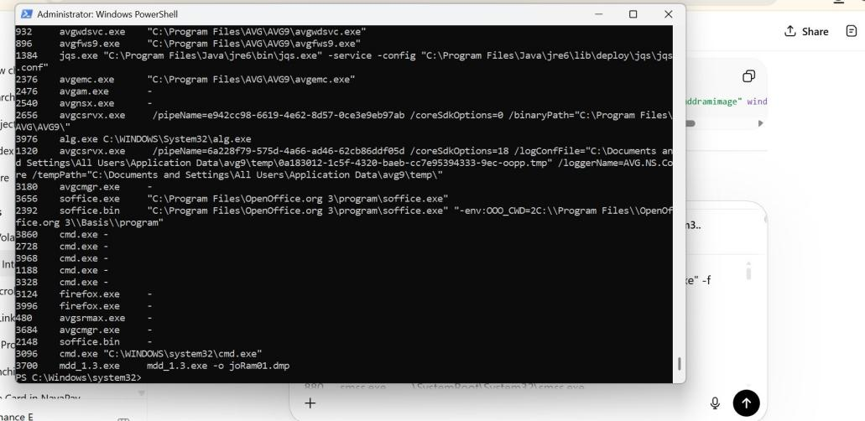

PART C — Memory Analysis & Investigation Conclusion

11. Memory Acquisition
Live memory was captured using mdd_1.3.exe (Memory DD v1.3). The prefetch artefact MDD_1.3.EXE-286446E8.pf confirms 4 executions, with the last at 2009-11-25 00:26:05 UTC. Critically, the tool was launched from E:\RAM\ — removable media — indicating the acquisition tool was brought in on an external drive.
RAM Image | jo-2009-11-16.mddramimage
Tool / Command | mdd_1.3.exe -o joRam01.dmp
Launched From | E:\RAM\ (removable media)
Prefetch Run Count | 4 executions — last at 2009-11-25 00:26:05 UTC
System Time at Capture | 2009-11-17 00:22:31 UTC
Analysis Tool | Volatility 3
Plugins Run | windows.info, pslist, pstree, cmdline, malfind, dlllist, truecrypt.Passphrase, netscan

12. Process Tree Analysis
The process tree at the time of memory capture shows Firefox, Python, Java, and OpenOffice all active — fully consistent with the disk-based findings.
Process | Parent | Significance
firefox.exe | explorer.exe | Browser active — targeted by patentauto.py via MozRepl port 4242
python.exe | explorer.exe | Python interpreter — patentauto.py possibly executing
javaw.exe | explorer.exe | Java runtime — diit-1.5.jar potentially active
soffice.bin | explorer.exe | OpenOffice — spawned multiple cmd.exe processes (suspicious)
cmd.exe | soffice.bin | Command prompt children of soffice.bin — unusual relationship
MSIMN.EXE | explorer.exe | Outlook Express — email client active at acquisition
mdd_1.3.exe | cmd.exe | Memory acquisition tool — launched from removable media (E:\RAM\)
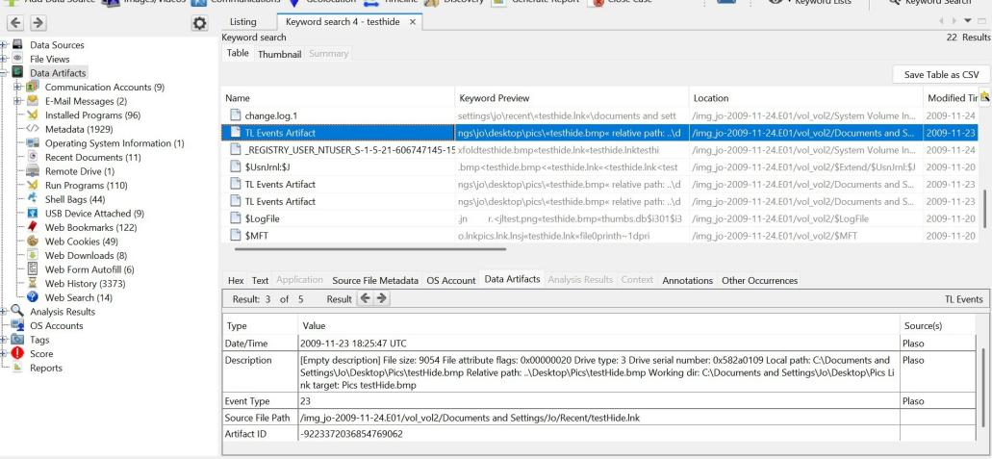
CAUTION: soffice.bin spawned multiple cmd.exe child processes — unusual behaviour suggesting macro execution or scripted automation through OpenOffice. This relationship is more indicative of suspicious activity than the malfind memory hits alone.

13. Malware Scan & DLL Analysis
The malfind plugin identifies memory regions with PAGE_EXECUTE_READWRITE permissions — common in injected shellcode or dynamically generated executable code.
Finding | Process | Assessment
PAGE_EXECUTE_READWRITE regions | soffice.bin | Suspicious but not confirmed malicious — OpenOffice uses executable memory legitimately
Java-related executable memory | javaw.exe | Expected — Java JIT compilation generates executable memory
DLL injection / reflective loading / rootkit | — | NOT confirmed
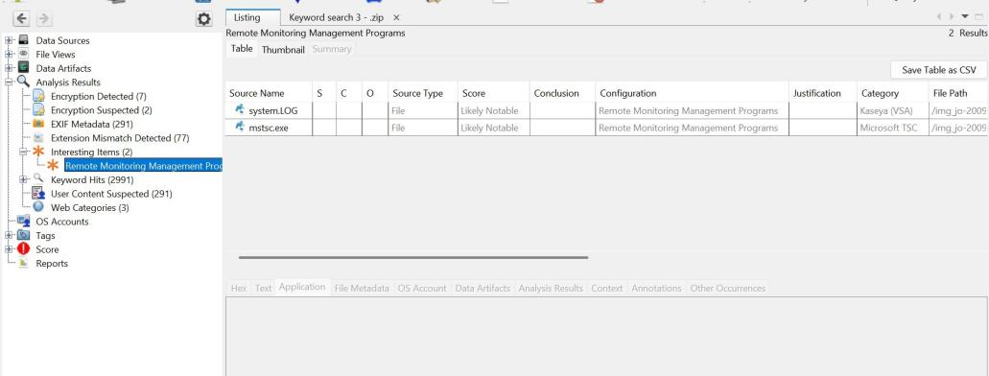
DLL analysis found no hidden or injected modules. All loaded libraries matched known installed software. CMD.EXE had a prefetch run count of 11, confirming significant command-line activity. windows.netscan was unsupported for Windows XP SP3; network reconstruction relied on disk-based evidence.
NOTE: No confirmed malware, DLL injection, or rootkit behaviour was identified. The activity profile is consistent with a technically sophisticated user — not a malware-compromised machine.

14. Final Investigation Conclusion

Summary of Findings
Area | Key Finding | Risk Level
Classified Document | STU.doc from noaa.gov — US DoC SECRET-level briefing with no legitimate justification | HIGH
Patent Script | patentauto.py — automated Firefox-controlled patent intelligence collection | HIGH
Steganography | DIIT (diit-1.5.jar) + testHide.bmp — steganographic capability demonstrated | HIGH
USB Activity | 2 USB devices connected at suspicious moments; file transfer confirmed by MD5 hash | HIGH
File Concealment | Files stored in a folder named "Hidden"; videos mirrored across USB images | MEDIUM
Memory — soffice | soffice.bin spawned cmd.exe processes — possible macro/automation execution | MEDIUM
Memory — Malfind | PAGE_EXECUTE_READWRITE in soffice.bin — suspicious but not confirmed malware | LOW
DLL / Rootkit | No DLL injection, reflective loading, or rootkit behaviour identified | CLEAR
Network | netscan unsupported for WinXP; disk confirms downloads from noaa.gov, python.org, apple.com | MEDIUM

Analytical Conclusion
The forensic investigation of Jo's workstation, USB images, and RAM capture presents a coherent and mutually corroborating pattern of suspicious insider activity. The evidence does not support a simple or innocent explanation.
On 2009-11-23, Jo installed Python and immediately created patentauto.py — a purpose-built browser automation script for structured, randomised, scheduled patent searches. An Alcor Micro USB flash drive was connected 51 seconds before the script was accessed. On the same day, DIIT and testHide.bmp were accessed 63 seconds apart — consistent with a steganographic test operation.
On 2009-11-24, an unknown USB device was connected 4 seconds before STU.doc was accessed — a classified US Department of Commerce STU-III briefing. Memory analysis confirmed Firefox, Python, Java, and OpenOffice were all active. soffice.bin spawned multiple cmd.exe children — an unusual relationship suggesting macro or automation execution.

CRITICAL: Overall Verdict: The totality of evidence is consistent with a deliberate insider threat operation involving (1) systematic automated patent intelligence collection via a custom Python/Firefox script, (2) demonstrated capability for steganographic data concealment, (3) unauthorised possession of a US government classified document, and (4) confirmed file transfer to removable media with deliberate concealment in a "Hidden" folder. Memory analysis did not identify confirmed malware — the activity profile is consistent with a technically sophisticated user conducting IP research and data exfiltration.

Recommended Next Steps
- Full forensic analysis of both USB images — deleted file recovery and full content inventory
- Re-examine testHide.bmp using DIIT itself to attempt payload extraction with likely keys
- Deep analysis of the soffice.bin → cmd.exe relationship — recover macro content from OpenOffice files
- Recover and analyse patentauto.py output data — patent records on disk or USB
- Determine the exact patents targeted — M57.biz's own or competitor intelligence?
- Clarify the business justification (if any) for downloading STU.doc from noaa.gov
- Legal process for Jo's email accounts, external communications, and full internet history
- Investigate contents of internalList.zip found in the AVG temp directory
- Serve legal process on M57.biz network logs for outbound connections on 2009-11-23 and 24

